Study of Women’s History

Student’s Name
Department, University
Course Number and Name
Instructor’s Name
Date

Study of Women’s History
The history of Rosie the Riveter is a perfect example of women's efforts and duties in society. Women have been great pillars of social development and family units since ancient times. Though society has been associating light jobs and house chores with women, women's history in World War II proves that women can work as hard as men. Following the women's initiatives in the past and present, society has slowly stopped stereotyping women in community duties and responsibilities (Museum, 2009). The history of American Women in World War II indicates that women can be perfect in-home activities and beyond given the right tools and motivation. Rosie's history should be used to motivate ladies to prove to them that their efforts are not limited.
Norman Rockwell played a crucial role in bringing the light to society through his painting, based on Rosie's story. The painting has played a significant role in preserving the history of American women's roles during World War II (Museum, 2009). According to ("Rosie the Riveter," 2018), Rosie the Riveter was among the women to defy all odds and stood out to play the roles known to be "men's" work. She was featured on cover pages of many articles because her story was unique and historical. When she joined the Women's Land Army, a few women were doing hard jobs. Like Rosie, Jean is an icon in the American history of War because she stood in place of men who left their duties to join other areas of work. Other women who played notable roles during the War include Grace Wallace. The period between 1940 and 1945 registered many women who joined men in the industrial labor force. The records of that era have played a significant role of encouragement over the years.
"WW2 people's war," (n.d.), is a source that explains the heroic history of Grace Wallace, a woman who left behind a great history after World War II. Grace was determined to support the American women in taking up the gaps left by men in the labor force. She was about sixteen years old when she first volunteered to work in the Women's Land Army. She was first stationed away from her home, but she willingly took up the responsibilities. She worked under unfavorable working conditions because, together with other women, they did not have the right protective gear for the dirty work. Her story was gathered and recorded by the BBC from the public members as they shared the wartime memories.
The video is another source that explains the history of an iconic woman, Jean Davis. She tells her story in an interview, explaining how she joined the Army during World War II (Museum, 2009). Her background as a girl guide shows how brave and determined she was in doing the odd jobs. Though society has been associating light jobs and house chores with women, women's history in World War II proves that women can work as hard as men. Following the women's initiatives in the past and present, society has slowly stopped stereotyping women in community duties and responsibilities. When she joined the Women's Land Army, a few women were doing hard jobs. Like Rosie, Jean is an icon in the American history of War because she stood in place of men who left their duties to join other areas of work (Museum, 2009). Other duties that were taken up by women include guarding and manual work in the factories. The few women featured in World War II history are a representation of thousands of others who worked hard to build the nation.
The two interview sources describe the work of the iconic women during World War II. The two women worked in the Women's Land Army. Before the Women's Army was formed, the field of War was known for men only. Upon World War's emergence, some brave women like Rosie, Jean, and Grace decided to challenge and work for the nation ("Rosie the Riveter," 2018). One thing in common between women is their courage to undertake challenging duties. In the interviews, they indicate that they knew the jobs were not easy, yet they agreed to work in the fields of War. The women were captured in history, wearing aprons and heavy attire to fit in the battlefield. Courage and determination are the two unifying factors between them.
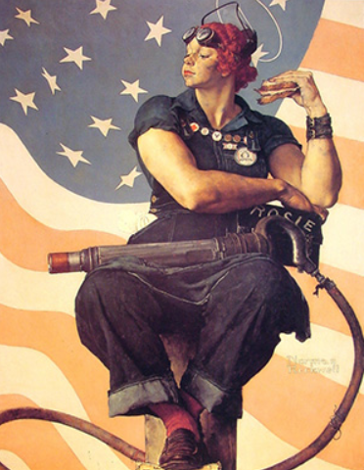
Figure 1: Norman Rockwell’s Rosie the Riveter taking lunch while holding her rival.
The women's images from the text play a crucial role in enlightening the U.S public and the women in society. In the images, women are captured in their working gears, ready to work. The working attire passes the message of hard work to the public. People should focus on the images to know how much the past legends worked for the current generation to get independence and productive land. Men should learn from history that women can be equally productive as men, given the right empowerment. The riffles in the images indicate how the women were brave to protect society from the enemies. The public should take the time to visit the museums and learn more about the history of World War II from the images.
Women in the U.S should use iconic women's images to prove to the world that they are crucial pillars in society. The images show how the women in the World War worked in harsh working conditions. In the image, Rosie holds a lunch container, which shows how the ladies had limited time for family care (Rosie the Riveter, 2018). The attires worn by the women show that they were engaged in manual work that required them to wear heavy and protective garments. The slogan, 'we can do it,' should be the leading motto of each day for all women. Women can work together to end gender stereotyping. Rosie the Riveter's story is an excellent example to every woman that shows how determination contributes to success. Every woman has the potential to make a change in society.
The three women in the sources have some common attributes. One of the similarities between them is the fact that they worked on battlefields. In the interviews, they all narrate how they joined the Women's Army to fill the gaps that were left by men (Rosie the Riveter, 2018). The second shared attribute is their determination. They all joined the field willingly and followed all the instructions that made them emerge victorious in the field. They all joined the Army services at young ages and were ready to work for a long time. However, Rosie stands out as a woman who could multitask. She worked at the Army and recruited other ladies in the same period. Unlike the other women, Grace is outgoing and determined to work in the field based on personal history. The women's images should be preserved for future generations to learn about the strength of a woman.

References
Museum, W. (2009, November 15). Jean Davis - My Time in the Land Army. YouTube. https://www.youtube.com/watch?v=kr1N45JGayU
Rosie the Riveter. (2018, March 3). Norman Rockwell Museum. https://www.nrm.org/rosie-the-riveter/
WW2 people's war. (n.d.). BBC. https://bbc.co.uk/ww2peopleswar

